Wasif Ali

Lab no 05

Instructor : Sir Mansoor
Submitted by : Wasif Ali (245187)
Class : BSCS F’24 4-B
Date : 03/11/2026
COMPUTER NETWORK
CISCO PACKET TRACING
Lab 05
Computer Network

- Accessing files through FTP server and Deleting files:

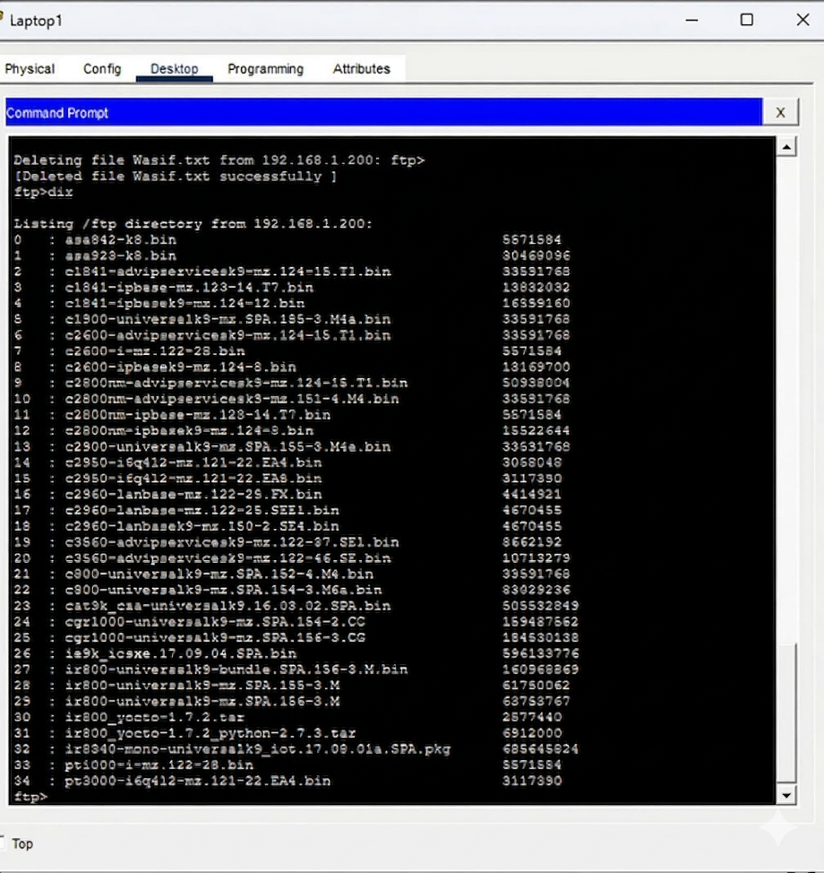

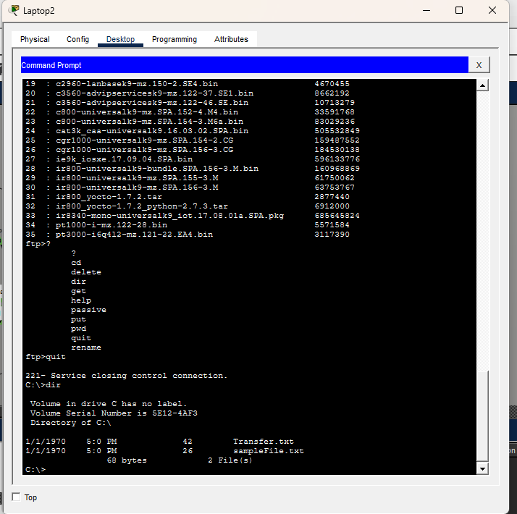
- Creating file on a laptop and transferring it to server using put command (Transfer.txt)

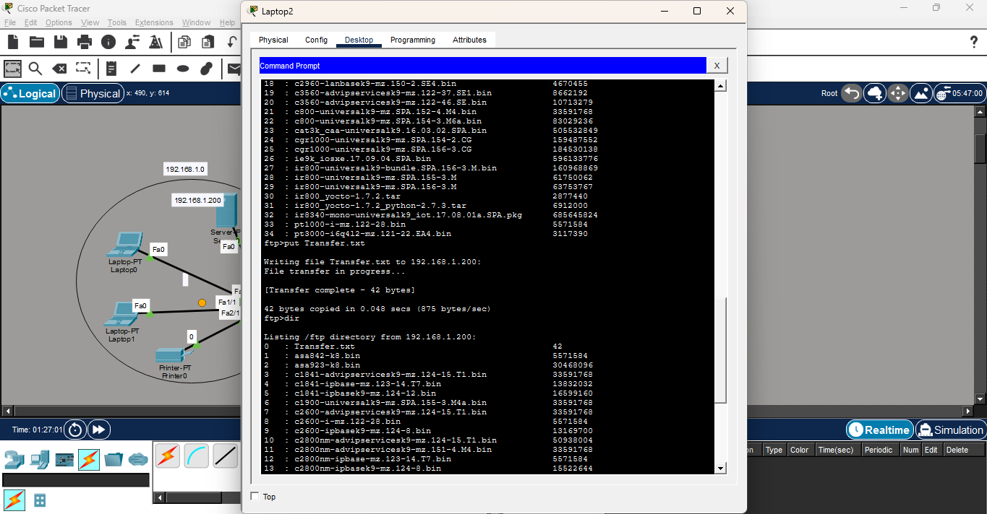
- Downloading files from Server
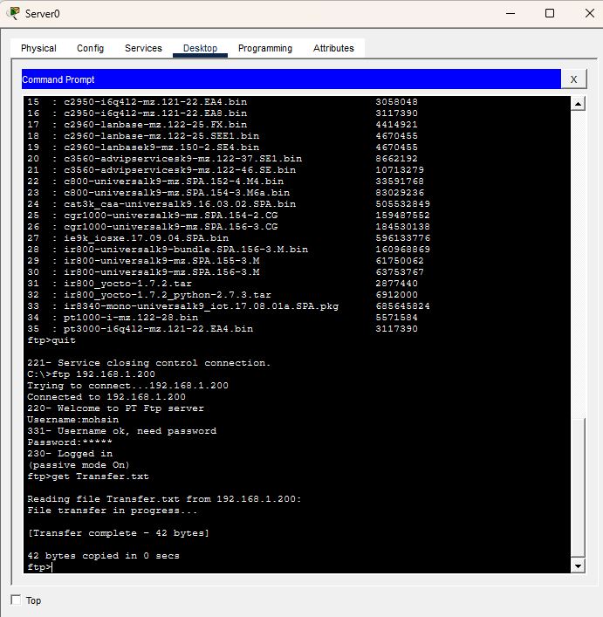
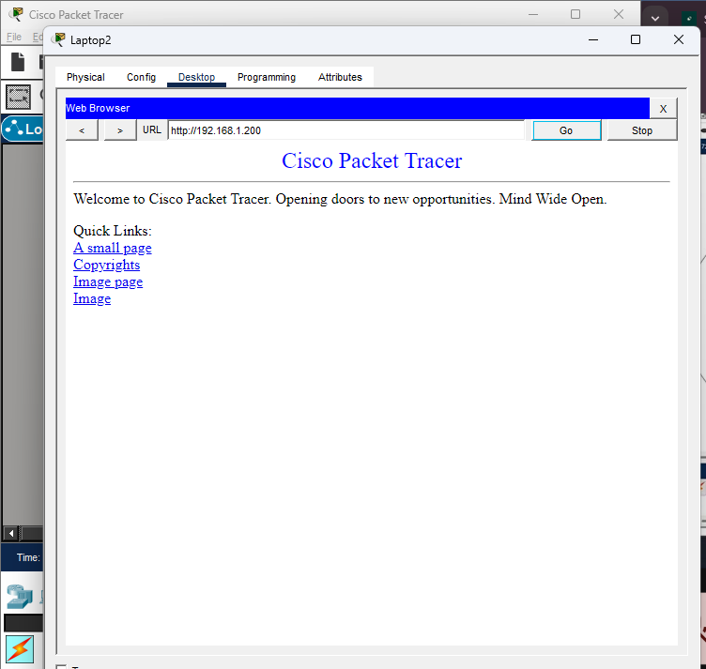
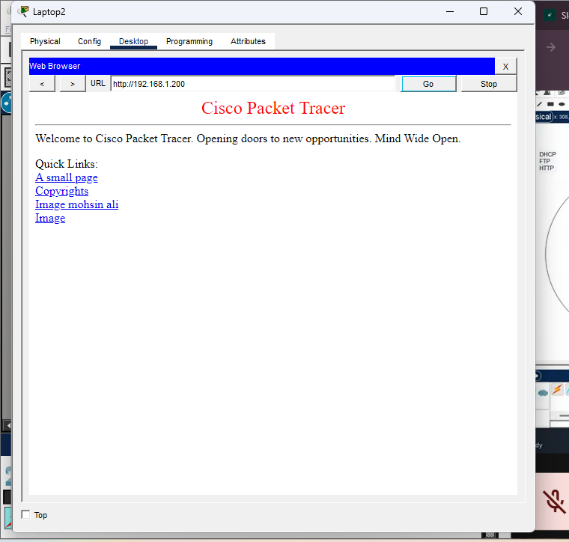

- Sending messages across networks successfully
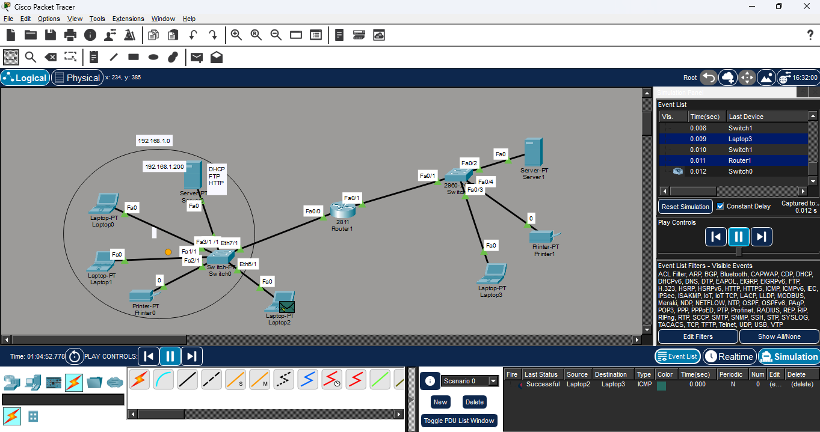

- Accessing Web page of other server over networks
